5.5: The for-each Loop

Let’s do an example of running the for-each loop. Start by creating a function called for_each_loop(). In this loop, we are going to create a list of names, then print each name in turn. Within the function you have created, enter the following code:

names = ["alice", "bob", "charlie"]

for name in names:

print(name)

You will also need to create a main function to run your for_each_loop() function. Your whole code document should be as follows:

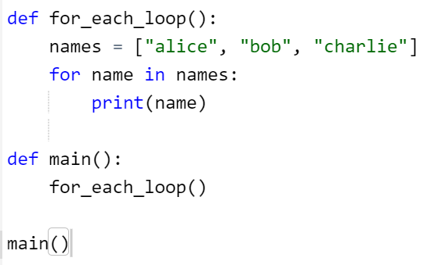

When we run this code, you should get the following output:

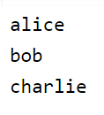

This block of code has essentially worked its way through the list, item by item, printing out the value at each index.